04 - Iteration Control Structures

Dept of Artificial Intelligence and Machine Learning | Rajalakshmi Engineering College

. 48

Ex. No. : 4.1 Date: 30/3/24

Register No.: 231501058 Name: M Harish

Factors of a number

Determine the factors of a number (i.e., all positive integer values that evenly divide into a number).

For example:

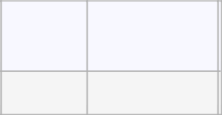

Input Result

20 12451020

PROGRAM

a=int(input())

for i in range(1,a+1):

if (a%i==0):

print(i,end=’ ‘)

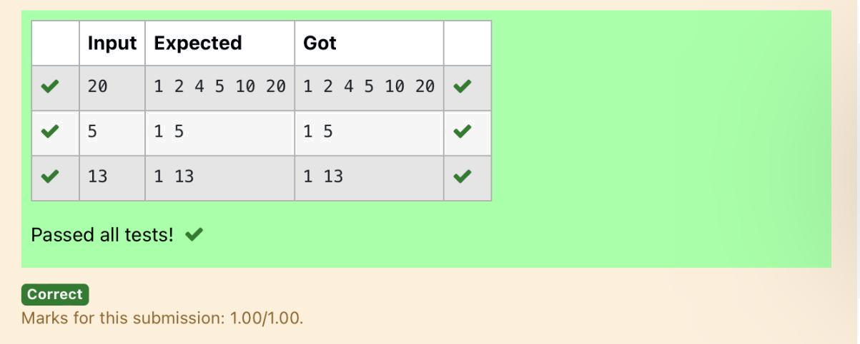

Dept of Artificial Intelligence and Machine Learning | Rajalakshmi Engineering College

. 49

Ex. No. : 4.2 Date: 30/3/24

Register No.: 231501058 Name: M Harish

Non Repeated Digit Count

Write a program to find the count of non-repeated digits in a given number N. The number will be passed to the program as an input of type int.

Assumption: The input number will be a positive integer number >= 1 and <= 25000.
Some examples are as below.

If the given number is 292, the program should return 1 because there is only 1 non-repeated digit '9' in this number

If the given number is 1015, the program should return 2 because there are 2 non-repeated digits in this number, '0', and '5'.

If the given number is 108, the program should return 3 because there are 3 non-- repeated digits in this number, '1', '0', and '8'.

If the given number is 22, the function should return 0 because there are NO non-- repeated digits in this number.

For example:

Input | Result
292 | 1
1015 | 2
108 | 3
22 | 0

Dept of Artificial Intelligence and Machine Learning | Rajalakshmi Engineering College

. 50

PROGRAM

num=int(input())

count=0

last=len(str(num))

for i in range(1,last):

temp=num%10

num=num//10

if (str(temp)not in str(num)):

count+=1

if(len(str(num))==1 and count==last-1):

print(count+1)

else:

print(count)

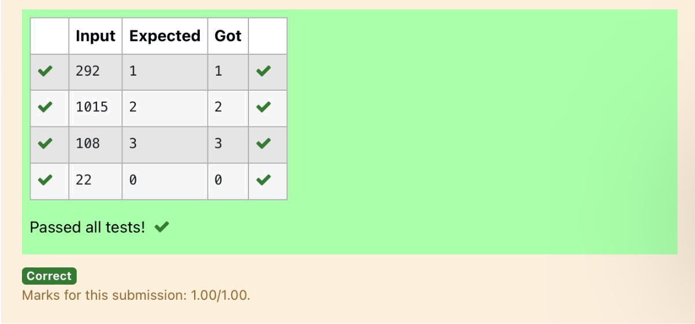

Dept of Artificial Intelligence and Machine Learning | Rajalakshmi Engineering College | . 51

Ex. No. : 4.3 Date: 30/3/24

Register No.: 231501058 Name: M Harish

Prime Checking

Write a program that finds whether the given number N is Prime or not. If the number is prime, the program should return 2 else it must return 1.

Assumption: 2 <= N <=5000, where N is the given number.

Example1: if the given number N is 7, the method must return 2

Example2: if the given number N is 10, the method must return 1

For example:

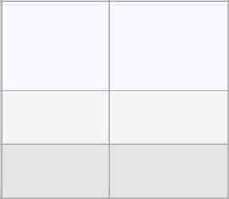

Input Result

7 2

10 1

PROGRAM

a=int(input())

count=0

for i in range(2,a):

if (a%i==0):

count+=1

if(count==0):

print(“2”)

else:

print(“1”)

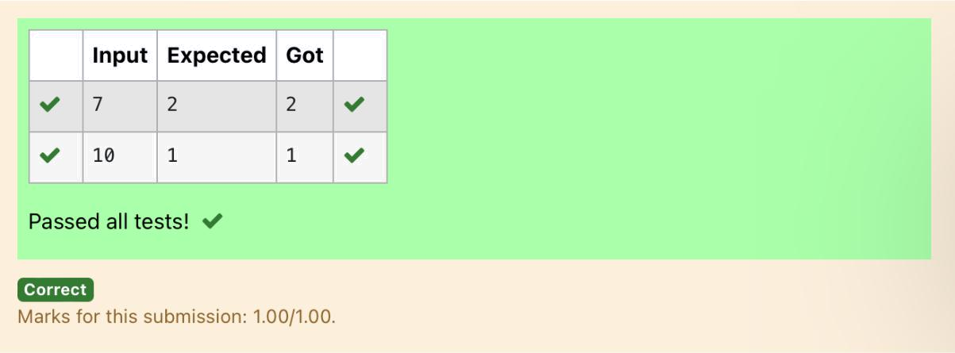

Dept of Artificial Intelligence and Machine Learning | Rajalakshmi Engineering College

. 52

Ex. No.

:
4.4
Date: 30/3/24

Register No.: 231501058

Name: M Harish

Next Perfect Square

Given a number N, find the next perfect square greater than N.

Input Format:

Integer input from stdin.

Output Format:

Perfect square greater than N.

Example Input:

10

Output:

16

PROGRAM

from math import sqrt

num=int(input())

while True:

a=int(sqrt(num))

if(num==pow(a,2)):

print(num)

break

else:

num+=1

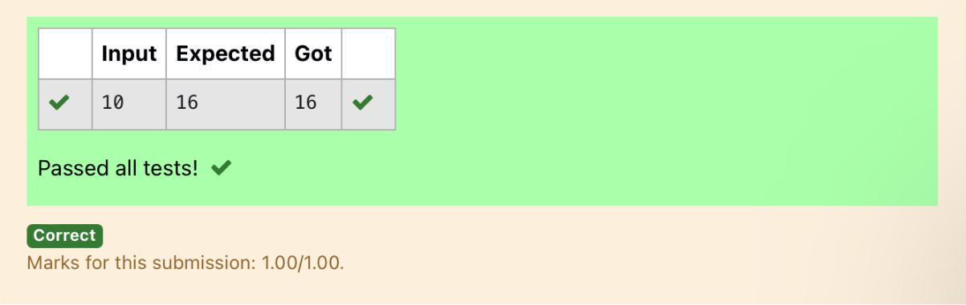

Dept of Artificial Intelligence and Machine Learning | Rajalakshmi Engineering College | . 53

Ex. No. : 4.5 Date: 30/3/24

Register No.: 231501058 Name: M Harish

Nth Fibonacci

Write a program to return the nth number in the fibonacci series. The value of N will be passed to the program as input.

NOTE: Fibonacci series looks like –

0, 1, 1, 2, 3, 5, 8, 13, 21, 34, 55, . . . and so on.

i.e. Fibonacci series starts with 0 and 1, and continues generating the next number as the sum of the previous two numbers.

- first Fibonacci number is 0,

- second Fibonacci number is 1,

- third Fibonacci number is 1,

- fourth Fibonacci number is 2,

- fifth Fibonacci number is 3,

- sixth Fibonacci number is 5,

- seventh Fibonacci number is 8, and so on.

For example: Input Output

78

PROGRAM

a=int(input())

b=0

c=1

d=0

for i in range(3,a+1):

d=c+b

b=c

c=d

print(d)

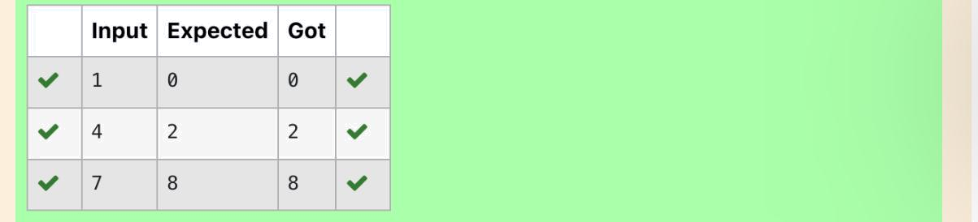

Dept of Artificial Intelligence and Machine Learning | Rajalakshmi Engineering College

. 54

Ex. No. : 4.6 Date:

Register No.: 231501058 Name: M Harish

Disarium Number

A Number is said to be Disarium number when the sum of its digit raised to the power of their respective positions becomes equal to the number itself. Write a program to print number is Disarium or not.

Input Format:

Single Integer Input from stdin.

Output Format:

Yes or No.

Example Input:

175

Output:

Yes

For Example:

Input Result

- Yes

- No

PROGRAM

num=int(input())

last=len(str(num))

temp=num

Sum=0

for i in range(0,last):

n=temp%10

temp=temp//10

sum=sum+(pow(n,last-i))

if (sum==num):

print(“Yes”)

else:

print(“No”)

Dept of Artificial Intelligence and Machine Learning | Rajalakshmi Engineering College

. 55

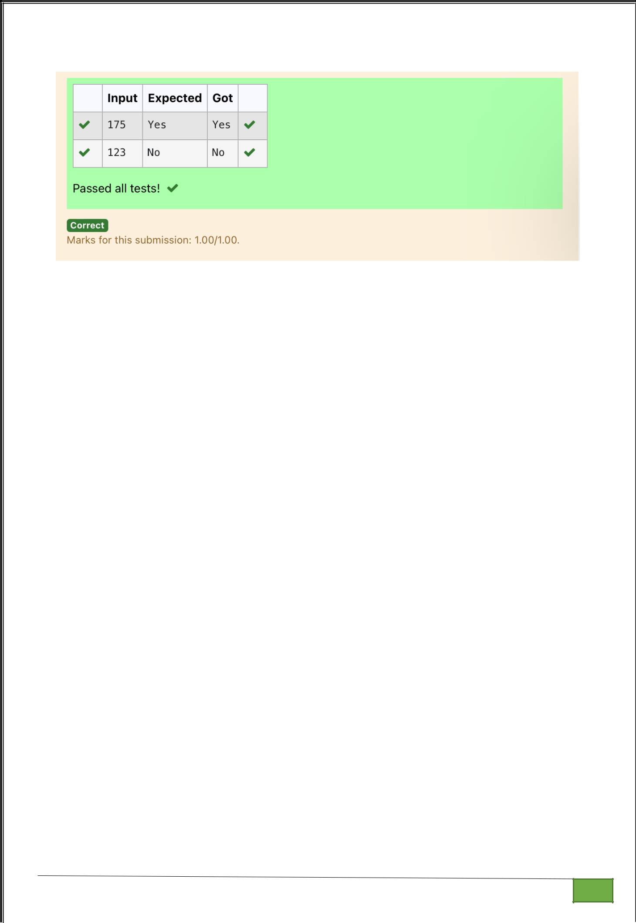

Dept of Artificial Intelligence and Machine Learning | Rajalakshmi Engineering College

. 56

Ex. No. : 4.7 Date: 30/3/24

Register No.: 231501058 Name: M Harish

Sum of Series

Write a program to find the sum of the series 1 +11 + 111 + 1111 + . . . + n terms (n will be given as input from the user and sum will be the output)

Sample Test Cases

Test Case 1

Input

4

Output

1234

Explanation:

As input is 4, have to take 4 terms.

1+11+111+1111

Test Case 2

Input

6

Output

123456

For example:

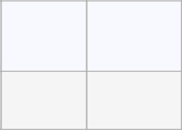

Input Result

3 123

PROGRAM

num=int(input())

sum1=0

for i in range(1,num+1):

st=’1’*i

sum1=sum1+int(st)

print(sum1)

Dept of Artificial Intelligence and Machine Learning | Rajalakshmi Engineering College

. 57

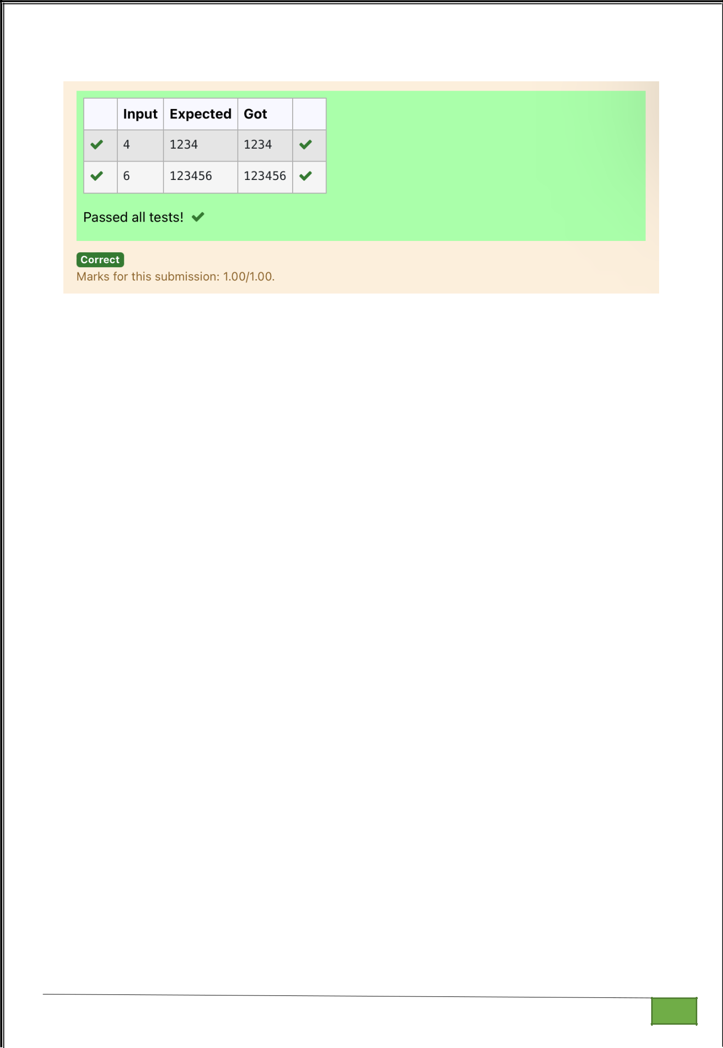

Dept of Artificial Intelligence and Machine Learning | Rajalakshmi Engineering College

. 58

Ex. No. : 4.8 Date: 30/3/24

Register No.: 231501058 Name: M Harish

Unique Digit Count

Write a program to find the count of unique digits in a given number N. The number will be passed to the program as an input of type int.

Assumption: The input number will be a positive integer number >= 1 and <= 25000.
For e.g.

If the given number is 292, the program should return 2 because there are only 2 unique digits '2' and '9' in this number

If the given number is 1015, the program should return 3 because there are 3 unique digits in this number, '1', '0', and '5'.

For example:

Input | Result
292 | 2
1015 | 3

PROGRAM

num=int(input())

count=0

last=len(str(num))

for i in range(1,last):

n=num%10

num=num//10

if (str(n)not in str(num)):

count+=1

print(count+1)

Dept of Artificial Intelligence and Machine Learning | Rajalakshmi Engineering College

. 59

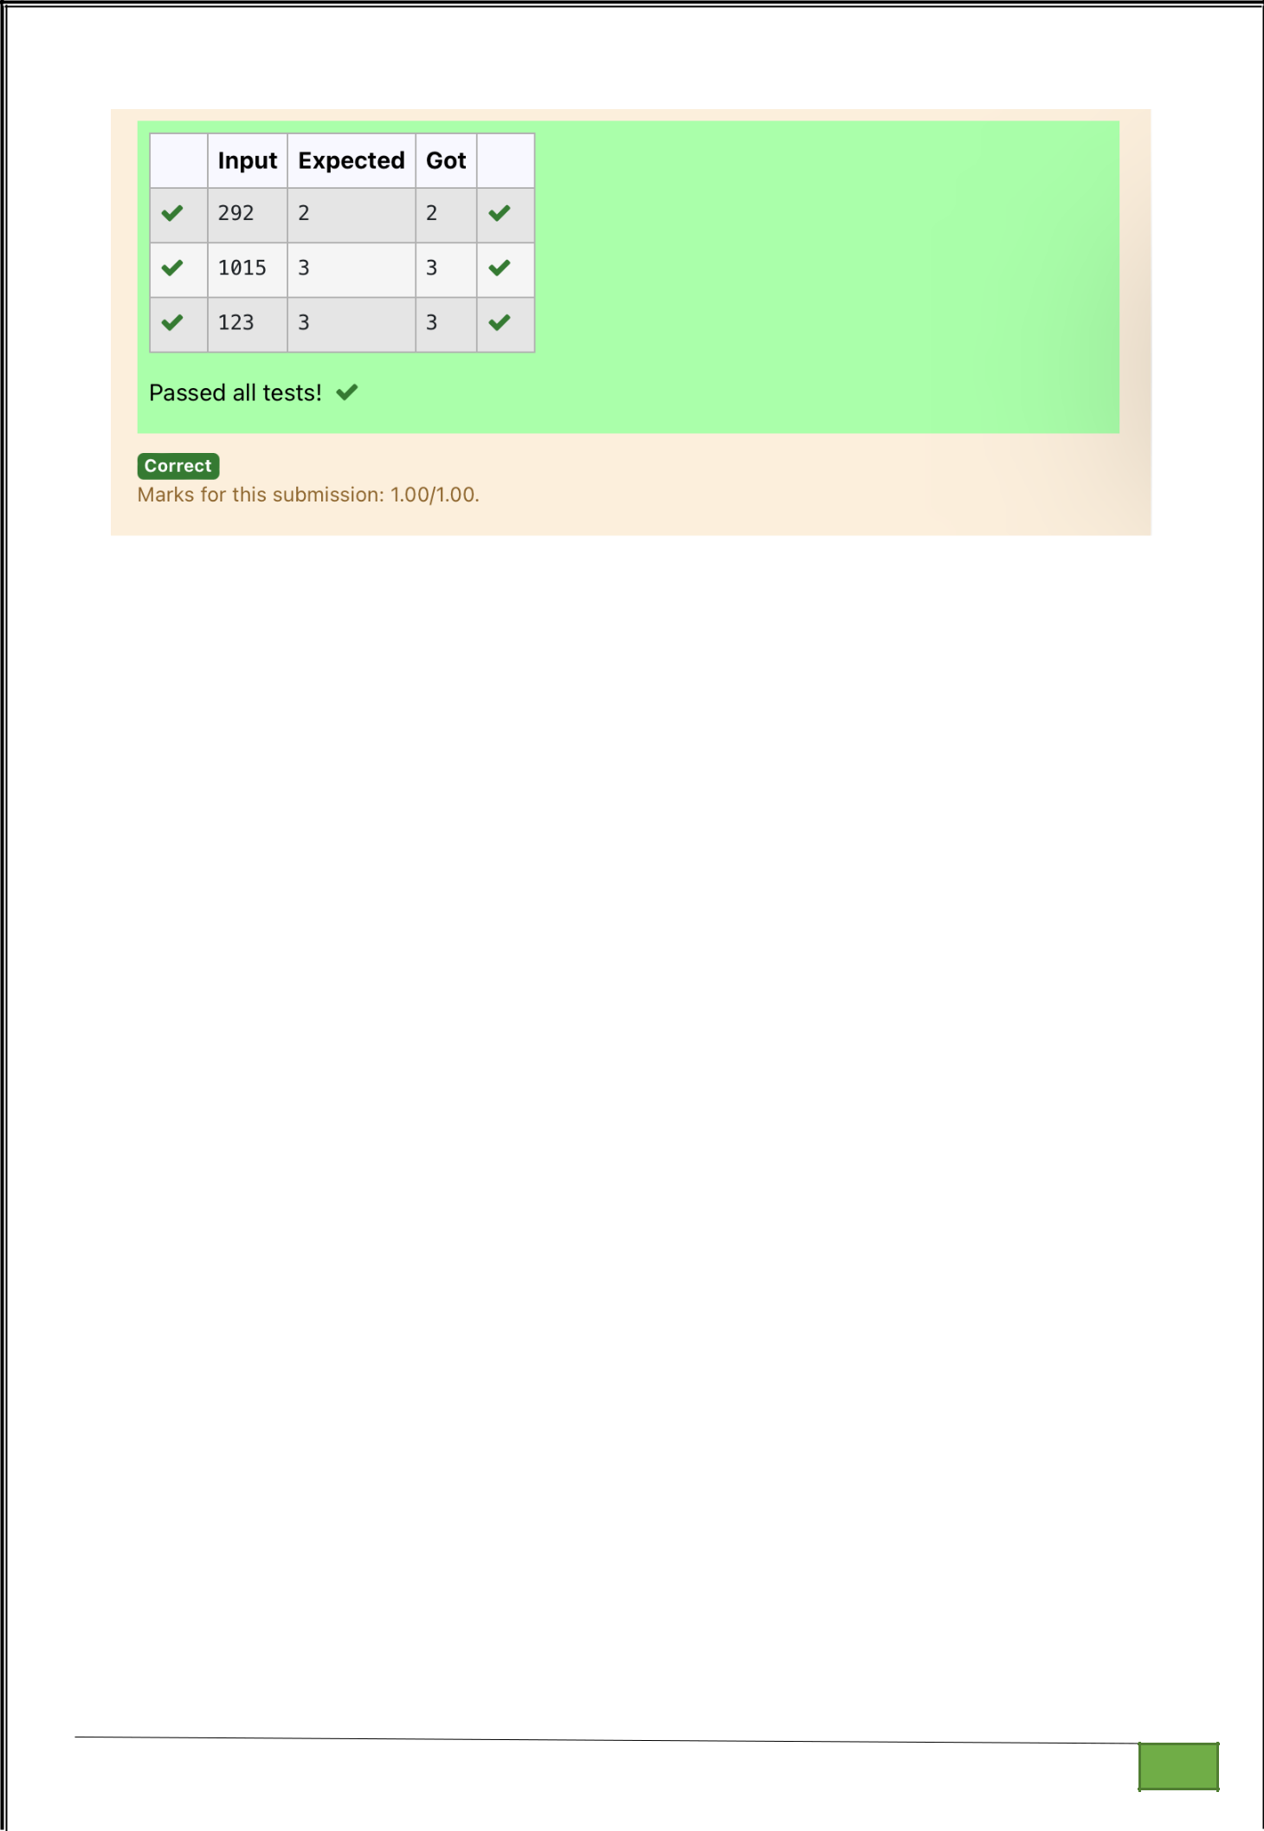

Dept of Artificial Intelligence and Machine Learning | Rajalakshmi Engineering College

. 60

Ex. No. : 4.9 Date: 30/3/24

Register No.: 231501058 Name: M Harish

Product of single digit

Given a positive integer N, check whether it can be represented as a product of single digit numbers.

Input Format:

Single Integer input.

Output Format:

Output displays Yes if condition satisfies else prints No.

For Example:

Input Output

- Yes

- No

PROGRAM

a=int(input())

count=0

for i in range(1,10):

for j in range(1,10):

if (i*j==a):

print(“Yes”)

count+=1

break

if(count>0):

break

if(count==0):

print(“No”)

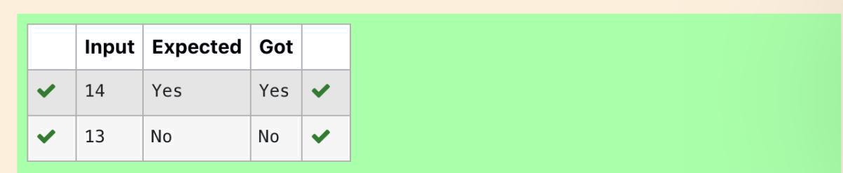

Dept of Artificial Intelligence and Machine Learning | Rajalakshmi Engineering College

. 61

Ex. No. : 4.10 Date: 30/3/24

Register No.: 231501058 Name: M Harish

Perfect Square After adding One

Given an integer N, check whether N the given number can be made a perfect square after adding 1 to it.

Input Format:

Single integer input.

Output Format:

Yes or No.

Example Input:

24

Output:

Yes

Example Input:

26

Output:

No

For example:

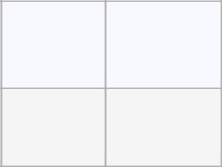

Input Result

24 Yes

PROGRAM

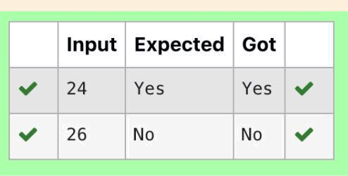

from math import sqrt

num=int(input())

fin=num+1

sq=int(sqrt(fin))

if (fin==pow(sq,2)):

print(“Yes”)

else:

print(“No”)

Dept of Artificial Intelligence and Machine Learning | Rajalakshmi Engineering College

. 62

